Final Report:
Hand Gesture Recognition System

Contents
1. Introduction 2
2. Objectives 2
3. Data Collection 2
4. Data Preprocessing 2
4.1 Resizing and Normalization 2
4.2 Data Augmentation 2
4.3 Visualization and Exploration 3
5. Model Selection and Architecture 4
5.1 Model Selection 4
5.2 Model Architecture 4
6. Model Training 4
7. Model Evaluation 5
8. Real-Time Gesture Recognition & Applications 5
8.1 Real-Time Recognition 5
8.2 Applications 5
9. Challenges 6
10. Future Improvements 6
11. Conclusion 6

1. Introduction
The Hand Gesture Recognition System is designed to recognize hand gestures in real-time, enabling interactive applications in areas such as human-computer interaction (HCI), virtual reality (VR), and accessibility tools for people with speech or mobility difficulties. The system leverages deep learning and computer vision techniques to classify hand gestures from images or live video feeds.
The main goal is to allow users to control devices, interact with virtual environments, or communicate without speech, thus enhancing accessibility and usability in real-world scenarios.

2. Objectives
The project has the following key objectives:
- Develop a model capable of recognizing hand gestures in real-time.
- Enable practical applications, such as controlling slides, devices, or interacting with VR systems.
- Provide accessibility support for people with speech or mobility difficulties.
- Lay the foundation for future research and improvement in gesture-based human-computer interaction systems.

3. Data Collection
- We used the Hand Gesture Recognition Database from Kaggle, which includes images of hand gestures representing the letters of the alphabet.
- The dataset was chosen for its availability, simplicity, and suitability for initial model training.

4. Data Preprocessing

4.1 Resizing and Normalization
All images were resized to a uniform shape suitable for the CNN input. Pixel values were normalized to a [0,1] range to improve convergence during training.

4.2 Data Augmentation
Data augmentation techniques were applied to increase dataset variability, prevent overfitting, and improve model generalization. The augmentations included: small rotations, zooming, and slight horizontal and vertical translations. No flipping was applied in this pipeline.

4.3 Visualization and Exploration
To better understand the dataset and ensure preprocessing was effective, two types of visualizations were performed:
- Class Distribution:
A count plot was generated to examine the number of images per hand gesture class. This visualization confirms that the dataset has a balanced representation of all gesture labels, which is crucial for avoiding class imbalance issues during model training.
- Pixel Variation Analysis:
A heatmap of the pixel-wise standard deviation across the raw training images was created. This helps to visualize which regions of the images vary the most, providing insight into areas of high information content that the model can learn from.
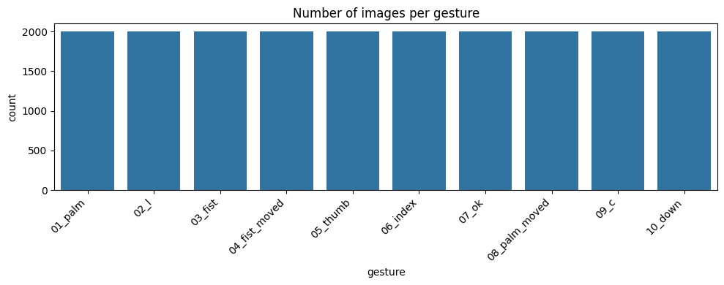
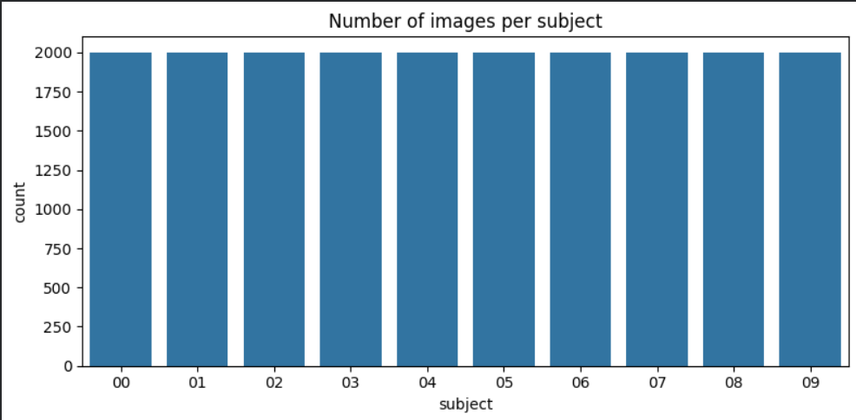
These visualizations ensure the quality and diversity of the data, and guide preprocessing and model training decisions.

5. Model Selection and Architecture

5.1 Model Selection
- Model selected: Convolutional Neural Network (CNN)
- Reason: effective for image and hand gesture recognition
- Output: classify into num_classes gesture categories

5.2 Model Architecture

The CNN model consists of three convolutional blocks with increasing filter sizes (32 → 64 → 128), each followed by batch normalization, max-pooling, and dropout for regularization. The flattened output is connected to a fully connected dense layer with 256 neurons and a final softmax layer for classification. The model uses the Adam optimizer with a learning rate of 0.0008 and categorical cross-entropy as the loss function.

Layer Type | Filters / Units | Kernel / Size | Activation | Dropout
Conv2D | 32 | 3x3 | ReLU | 0.25
Conv2D | 32 | 3x3 | ReLU | -
MaxPooling2D | - | 2x2 | - | -
Conv2D | 64 | 3x3 | ReLU | 0.30
Conv2D | 64 | 3x3 | ReLU | -
MaxPooling2D | - | 2x2 | - | -
Conv2D | 128 | 3x3 | ReLU | 0.40
Conv2D | 128 | 3x3 | ReLU | -
MaxPooling2D | - | 2x2 | - | -
Dense | 256 | - | ReLU | 0.50
Dense (Output) | num_classes | - | Softmax | -

6. Model Training
- Optimizer: Adam with learning rate 0.0008
- Loss function: Categorical Crossentropy
- Metrics: Accuracy
- Epochs: 15
- Batch size: 64
- Data Augmentation: rotation, zoom, width/height shift, shear, horizontal flip
- Callbacks: EarlyStopping (patience=7, restore best weights), ReduceLROnPlateau (patience=3, factor=0.3, min_lr=1e-6)
- Validation: monitored on validation set during training
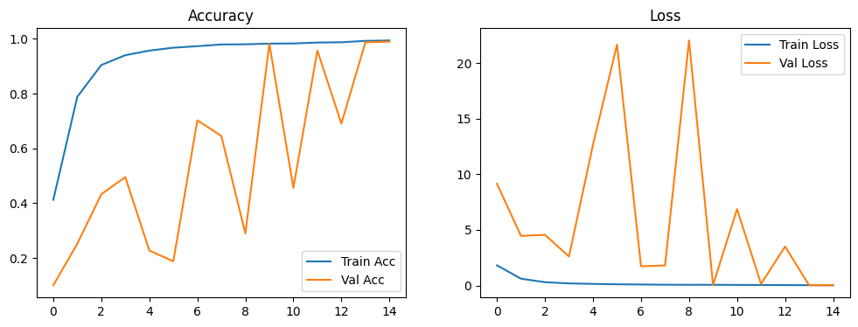
- Output: trained CNN model ready for evaluation

7. Model Evaluation
- Model evaluated on the test set.
- Test accuracy and loss calculated.
- Confusion matrix and classification report used to analyze performance per gesture class.
- Results indicate high accuracy in recognizing all hand gesture classes.
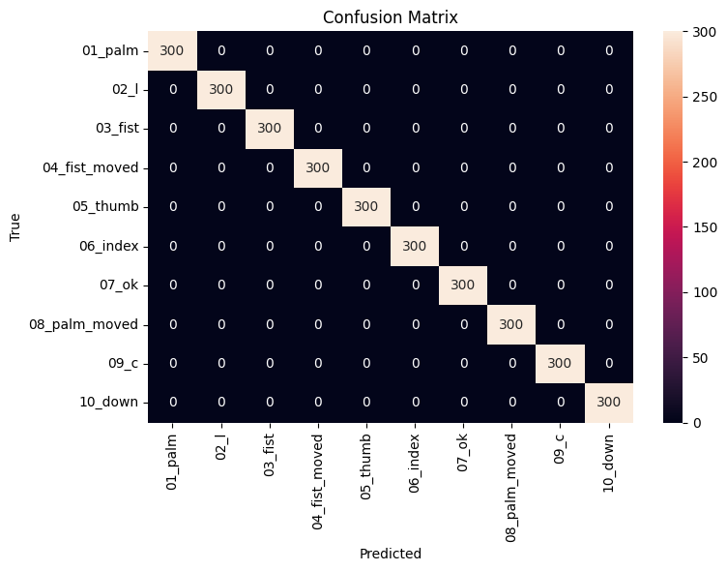

8. Real-Time Gesture Recognition & Applications

8.1 Real-Time Recognition
A real-time system was implemented using OpenCV to capture live video and classify gestures using the trained model.

8.2 Applications
- Controlling devices (moving a cursor, flipping slides)
- Virtual/Augmented reality interaction
- Accessibility tools for non-verbal communication

9. Challenges
Challenge | Description
Limited Dataset | Only Hand Gesture Recognition Database was used, limiting gesture variety.
Variations in Gestures | Hand positions, lighting, and backgrounds made recognition harder.
Real-Time Performance | Maintaining fast and accurate predictions on live video was challenging.

10. Future Improvements
- Expand Dataset – Add more gestures and real-world variations
- Improve Real-Time Performance – Optimize model speed and reduce latency
- Use Advanced Models – Experiment with newer pre-trained architectures
- Integration with VR/AR – Apply gesture recognition in virtual or augmented reality
- Accessibility Applications – Support people with speech or mobility difficulties
- Cross-Platform Compatibility – Make the system work on multiple devices and operating systems

11. Conclusion
The Hand Gesture Recognition System demonstrates the potential of combining deep learning and computer vision for real-time gesture recognition. The system enables interactive applications and provides a foundation for accessibility solutions. With future improvements, it can become more accurate, faster, and applicable in a wide range of real-world scenarios, enhancing human-computer interaction and communication tools.

